Universidad Industrial de Santander

Grupo de Investigación HDSP

Escuela de Ingeniería de Sistemas e Informática

PhD. Henry Arguello Fuentes Undergraduate Studies

Numerical Analysis

# Homework #2

The solution of Nonlinear Equations *f*(*x*) = 0

DATE: 9th June 2020 DUE : **21th June 2020**

## 1 INDICATIONS

1. You **must** fill this sheet with just the answer for each problem and return it to the professor. However, you have to present the process on a separate exam sheet.
2. Answers with no process are **not valid**.
3. Make all calculations with 5 decimal places of precision.

## 2 THE SOLUTION OF NONLINEAR EQUATIONS

1. (1.0 point) The Van der Waals equation relates the density of fluids to the pressure *P*, volume *υ*, and temperature *T* conditions. Thus, it is a thermodynamic equation of state given by,

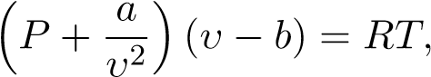 (2.1)

where, *a,b* and *R* are constasts that depends on the gas.

If *P* = 5, *a* = 0*.*245, *b* = 0*.*0266, *R* = 0*.*08206 and *T* = 350,

a) Determine a nonlinear equation *f*(*υ*) = 0 that allows to calculate the volume *υ* by finding its root.

### *f*(*υ*) =

1. Use the Secant method to find the root of the nonlinear equation in literal a). Use *υ*0 = 35, *υ*1 = 30 and iterate until achieving a precision of |*υ*−*υk*−1| *<* 1×10−5 *Make all calculations with 5 decimal places*.

Iteration rule: *υk*+1 =

|  |  |  |  |  |
| --- | --- | --- | --- | --- |
| *k* | *υk* | *f***(***υk***)** | *|υk − υk−***1***|* | *Ek* **=** *|***5***.***76234** *− υk*| |
| 0 | 35 | 178651.4848 | 5 |  |
| 1 | 30 | 108755.1848 |  |  |
| 2 | 22.22025 | 40458.55164 |  |  |
| 3 | 17.61156 | 18269.63103 |  |  |
| 4 | 13.81693 | 7623.51053 |  |  |
| 5 | 11.09965 | 3246.47410 |  |  |
| 6 | 9.08423 | 1343.33810 |  |  |
| 7 | 7.66163 | 538.28591 |  |  |
| 8 | 6.71043 | 198.95291 |  |  |
| 9 | 6.15274 | 61.81209 |  |  |
| 10 | 5.90138 | 13.14840 |  |  |

*Ph.D. Henry Arguello Fuentes Page 1 of 5*

1. The rate of convergence for the secant method is given by, *R* ≈ 1*.*618. Thus, the relation between successive error terms is *Ek*+1 = *A*|*Ek*|1*.*618*.* Use information found in table of literal b), to calculate the value of *A*.

*A* =

1. (1.0 point) Let *f*(*x*) = *x*3 − 3*x* − 2
   1. Find the Newton-Rapshon formula *pk* = *g*(*pk*−1)

Iteration rule: *pk* =

* 1. Start with *p*0 = 2*.*1 and find *p*1*,p*2*,p*3*,p*4 and *p*5.

|  |  |  |  |  |  |
| --- | --- | --- | --- | --- | --- |
| *k* |  | *pk* | *f***(***pk***)** | *f0***(***pk***)** | *|pk − pk−***1***|* |
| 0 | 2*.*1 |  | 0.96100 | 10.23000 |  |
| 1 | 2.00606 |  | 0.05477 | 9.07284 |  |
| 2 | 2.00002 |  | 0.00022 | 9.00029 |  |
| 3 | 2.00000 |  | 0.00000 | 8.99999 |  |
| 4 | 2.00000 |  | 0.00000 | 8.99999 |  |
| 5 | 2.00000 |  | 0.00000 | 8.99999 |  |

* 1. Is the sequence converging quadratically or linearly?

Answer:

1. (1.0 point) The world population *N* can be simulated by a function that grows in proportion to the number of individuals in a given time *t*. This is called the *logistic function* and it follows the equation (2.2),

 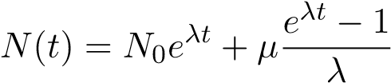*,* (2.2)

where, *N*0 = *N*(*t*0) is the amount of individuals at the beginning of the simulation period, *λ* is the growth rate and *µ* simulates the immigration rate.

**Figure 2.1:** World population growth

Suppose that *N*(*t*0) = 1000, *µ* = 435 and *N*(*t*1) = 1564.

* 1. Determine a nonlinear equation *g*(*λ*) = 0 that allows to calculate the growth rate *λ* by finding its root.

### *g*(*λ*) =

b) Use the Newton method to find the root of the nonlinear equation in literal a). Use *λ*0 = 0*.*5 and iterate until achieving a precision of |*λk* − *λk*−1| *<* 1 × 10−6 *Make all calculations with 5 decimal places*.

Iteration rule: *λk*+1 =

|  |  |  |  |  |  |
| --- | --- | --- | --- | --- | --- |
| *k* |  | *λk* | *g***(***λk***)** | *g0***(***λk***)** | *|λk − λk−***1***|* |
| 0 | 0*.*5 |  |  |  | − − − − − |
| 1 |  |  |  |  |  |
| 2 |  |  |  |  |  |
| 3 |  |  |  |  |  |
| 4 |  |  |  |  |  |
| 5 |  |  |  |  |  |
| 6 |  |  |  |  |  |
| 7 |  |  |  |  |  |
| 8 |  |  |  |  |  |
| 9 |  |  |  |  |  |
| 10 |  |  |  |  |  |

dsfs dsfsd

1. (1.0 point) Determine rigorously if each function has an unique fixed point.

a) 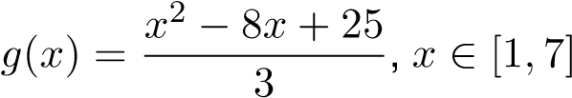

|  |  |
| --- | --- |
| fixed point existence theorem verification: | unique fixed point theorem verification: |
| Sketch *g*(*x*) and *y* = *x* | Sketch *g*0(*x*) |

Use the starting value *p*0 = 3*.*15 and compute *p*1*,p*2*,p*3*,p*4 and *p*5.

|  |  |  |  |  |  |
| --- | --- | --- | --- | --- | --- |
| *p*0 | *p*1 | *p*2 | *p*3 | *p*4 | *p*5 |
| 3*.*15 |  |  |  |  |  |
| Do the sequence converge? | |  |  |  |  |

Use the starting value *p*0 = 3*.*25 and compute *p*1*,p*2*,p*3*,p*4 and *p*5.

|  |  |  |  |  |  |
| --- | --- | --- | --- | --- | --- |
| *p*0 | *p*1 | *p*2 | *p*3 | *p*4 | *p*5 |
| 3*.*25 |  |  |  |  |  |
| Do the sequence converge? | |  |  |  |  |

b) 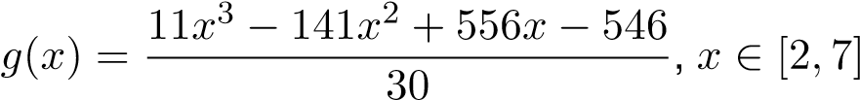

|  |  |
| --- | --- |
| fixed point existence theorem verification: | unique fixed point theorem verification: |
| Sketch *g*(*x*) and *y* = *x* | Sketch *g*0(*x*) |

Use the starting value *p*0 = 4*.*1 and compute *p*1*,p*2*,p*3*,p*4 and *p*5.

|  |  |  |  |  |  |
| --- | --- | --- | --- | --- | --- |
| *p*0 | *p*1 | *p*2 | *p*3 | *p*4 | *p*5 |
| 4*.*1 |  |  |  |  |  |
| Do the sequence converge? | |  |  |  |  |

Use the starting value *p*0 = 6*.*95 and compute *p*1*,p*2*,p*3*,p*4 and *p*5.

|  |  |  |  |  |  |
| --- | --- | --- | --- | --- | --- |
| *p*0 | *p*1 | *p*2 | *p*3 | *p*4 | *p*5 |
| 6*.*95 |  |  |  |  |  |
| Do the sequence converge? | |  |  |  |  |

1. 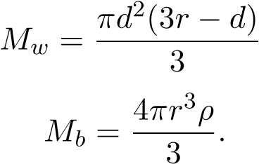(1.0 point) Archimedes’ principle indicates that the upward buoyant force that is exerted on a body immersed in a fluid, is equal to the weight of the fluid that the body displaces, and it acts in the upward direction at the centre of mass of the displaced fluid. Suppose that a sphere of radius *r* = 15 constructed with a material of density *ρ* = 0*.*638 is submerged in water to a depth *d* as shown in Fig. 2.2. According to Archimedes’ principle, the mass of water displaced *Mw* is equal to the mass of the ball *Mb*, thus,

*M*

*w*

=

*M*

*b*

(2.3)

where,

*,*

(2.4)

(2.5)



𝑑𝑒𝑛𝑠𝑖𝑡𝑦

𝜌



𝑑𝑒𝑝𝑡ℎ

𝑑

𝑟𝑎𝑑𝑖𝑢𝑠

𝑟

**Figure 2.2:** Sphere submerged in water

a) Use equations (2.3), (2.4) and (2.5) to find a nonlinear equation of the form *f*(*d*) = 0, that allows to determine the depth *d*.

### *f*(*d*) =

1. Use the bisection method of Bolzano to calculate the roots of the nonlinear equation in literal a). Use *a*0 = 17*.*6 and *b*0 = 18 and iterate until achieving a precision of |*ck* − *ck*−1| *<* 1 × 10−3. *Make all calculations with 5 decimal places*.

|  |  |  |  |  |  |  |  |
| --- | --- | --- | --- | --- | --- | --- | --- |
| *k* | *ak* | *bk* | *ck* | *f***(***ak***)** | *f***(***bk***)** | *f***(***ck***)** | *|ck − ck−***1***|* |
| 0 | 17*.*6 | 18 |  |  |  |  |  |
| 1 |  |  |  |  |  |  |  |
| 2 |  |  |  |  |  |  |  |
| 3 |  |  |  |  |  |  |  |
| 4 |  |  |  |  |  |  |  |
| 5 |  |  |  |  |  |  |  |
| 6 |  |  |  |  |  |  |  |
| 7 |  |  |  |  |  |  |  |
| 8 |  |  |  |  |  |  |  |
| 9 |  |  |  |  |  |  |  |
| 10 |  |  |  |  |  |  |  |

1. **Without doing iterations**, determine the required number of iterations *N* to guarantee that the midpoint *cN* is an aproximation to a zero of the nonlinear equation in literal a) with an error less than *δ* = 1 × 10−15, where *a*0 = 17 and *b*0 = 18.

*N* =

*Ph.D. Henry Arguello Fuentes Page 5 of 5*